SQL SELECT COMMANDS

1-

SELECT Cus_Name, Cus_Lname, Order_Amount, Order_Date FROM Customer

LEFT JOIN Ordering

ON Customer.Cus_ID = Ordering.Cus_ID

WHERE Order_Date >= '2022-11-09'

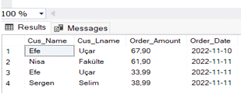

2-

SELECT Cus_Name, Cus_Lname, Order_Amount, Order_Date FROM Customer

INNER JOIN Ordering

ON Customer.Cus_ID = Ordering.Cus_ID

WHERE Order_Status='N'

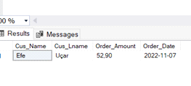

3-

SELECT Cus_Name, Cus_Lname, Order_Status, Order_Notes FROM Customer

LEFT JOIN Ordering

ON Customer.Cus_ID = Ordering.Cus_ID

WHERE Order_Notes IS NULL

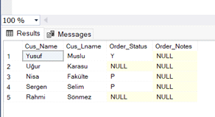

4-

SELECT Food_Id FROM Rating

WHERE Food_ID IN (SELECT Food_Id FROM Rating WHERE Rat_ID > 4)

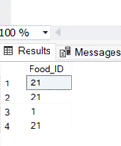

5-

SELECT Food_Id,Food_Name FROM Food

WHERE Food_ID>12 AND Food_Name LIKE '%burger%'

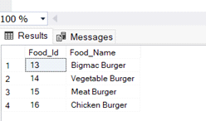

6-

SELECT Menu_ID, COUNT(DISTINCT Food_ID) AS ID FROM Food

GROUP BY Menu_ID HAVING COUNT(DISTINCT Food_ID)>4

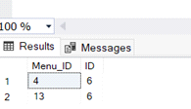

7-

SELECT Res_Name, Res_Adress, Menu_Name FROM Restaurant

LEFT JOIN Menu

ON Restaurant.Res_ID = Menu.Res_ID

WHERE Loca_ID = '2'

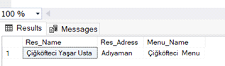

8-

SELECT Cus_ID,Order_ID,

Sum(Order_Amount) AS Sum_Order , MAX(Order_Amount) AS Max_Amount FROM Ordering

GROUP BY Cus_ID,Order_ID

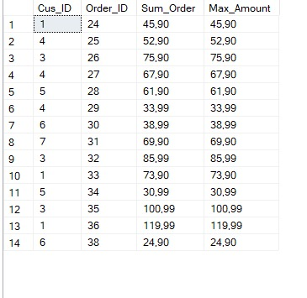

9-

SELECT cus_ID ,Cus_Name,Cus_Lname, Cus_Email FROM Customer

WHERE Cus_Email LIKE '%gmail.com%'

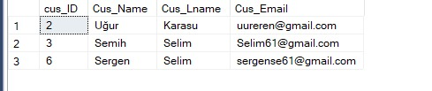

10-

SELECT*FROM Customer

WHERE Cus_Email NOT LIKE '%@%'

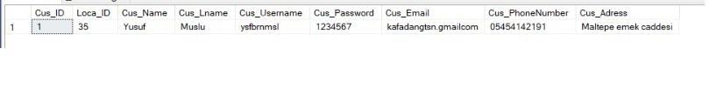

11-

SELECT Res_Name,Loca_ID,Res_Adress

FROM Restaurant

WHERE Res_Adress='Pozcu' OR Loca_ID=35

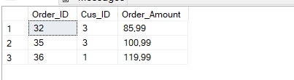

12-

SELECT Order_ID,Cus_ID,Order_Amount FROM Ordering

WHERE Order_Amount BETWEEN 80 AND 120



13-

SELECT Cus_Name,Cus_Lname,cus.Cus_ID,COUNT(Order_ID) AS Order_Count,AVG(Order_Amount) AS avg_order

FROM Ordering ord

INNER JOIN Customer cus

ON CUS.Cus_ID=ord.Cus_ID

GROUP BY cus.Cus_ID,Cus_Name,Cus_Lname

HAVING COUNT(Order_ID)>1

ORDER BY avg_order DESC

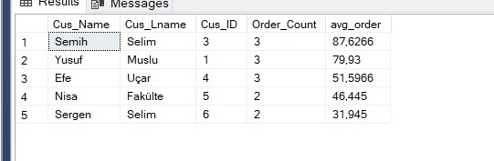

14-

SELECT cus.Cus_ID, Cus_Name,Cus_Lname,Order_Amount

FROM Customer cus

INNER JOIN Ordering ordering

ON cus.Cus_ID=ordering.Cus_ID

WHERE Order_Amount<55

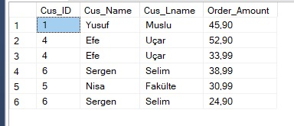

15-

SELECT fdd.Food_ID, Food_Name,Comments FROM Food fdd

INNER JOIN Rating rat

ON FDD.Food_ID=rat.Rat_ID

WHERE Comments IS NOT NULL

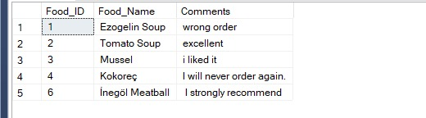

16-

SELECT Res_Name,ord.Order_ID FROM Restaurant res

LEFT JOIN Ordering ord

ON res.Res_ID=ord.Res_ID

WHERE ord.Res_ID is null

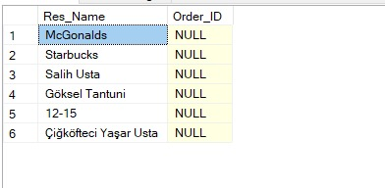

17-

-SELECT Res_Name,Res_Adress,Comments FROM Restaurant res

LEFT JOIN Rating rat

ON res.Res_ID=rat.Res_ID

WHERE Comments IS NOT NULL

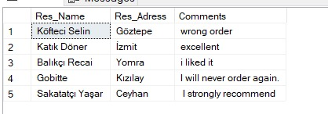

18-

SELECT Cus_ID, Res_ID,Rat_ID FROM Rating

WHERE Comments IS NULL

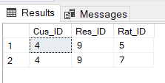

19-

SELECT Res_Name, Menu_Name FROM Restaurant

INNER JOIN Menu ON Restaurant.Res_ID = Menu.Res_ID

WHERE EXISTS (SELECT * FROM Menu WHERE Res_ID = Restaurant.Res_ID AND Menu_Name LIKE 'FR%')

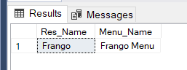

20-

SELECT Res_Name, Menu_Name FROM Restaurant

LEFT JOIN Menu ON Restaurant.Res_ID = Menu.Res_ID

UNION SELECT Res_Name, Menu_Name FROM Restaurant

INNER JOIN Menu ON Restaurant.Res_ID = Menu.Res_ID

WHERE Res_Name = 'Mcdonalds'

